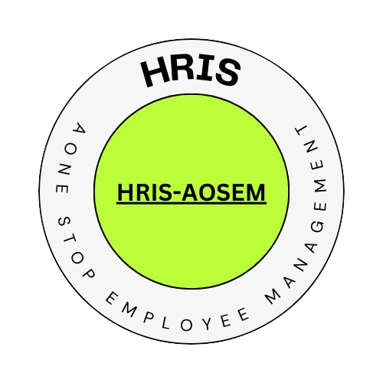

**Human Resources Information System**

**Blk 21, Lot 14, Area H, Phase III, Barangay San Rafael V, CSJDM. Bulacan**

**+639922859502 - hrisaonestopemployeemanagementapplication@gmail.com**

**CERTIFICATE OF EMPLOYMENT**

**TO WHOM IT MAY CONCERN**

This is to certify that JHON RIYEL MENTE is an employee of the Company as IT HEAD.

As per our record of this office, he/she was employed by the company since 2024-04-15 to present.

This certification is being issued upon the request of the above name employee for SSS LOAN.

For Verification purposes, please contact Company Human Resources Office or email hrisaonestopemployeemanagementapplication@gmail.com.

Issued on 2024-04-23, at the City of San Jose del Monte, Bulacan, Philippines.

Prepared by:

**MARK GUERRERO - HR OFFICER**

Approved by:

**JHON RIYEL MENTE - PRESIDENT**